BODYMAP
(This must be completed at time of observation)

Name of Child: |  |  | Date of Birth:
Name of Staff: |  |  | Job title:
Date and time of observation:

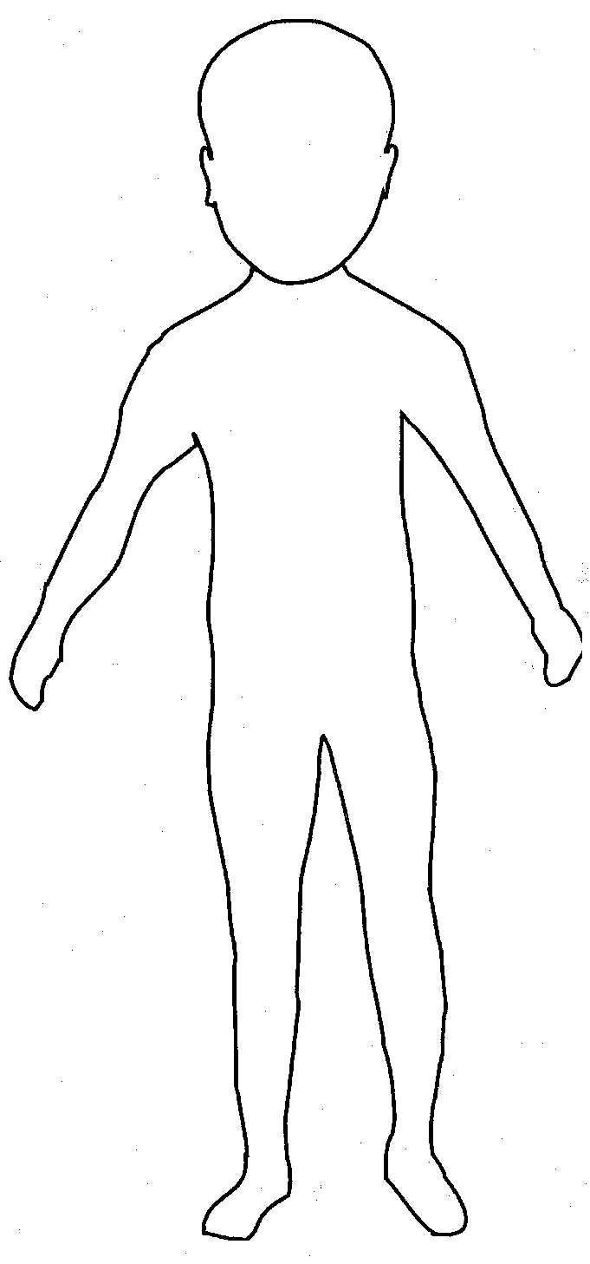 | 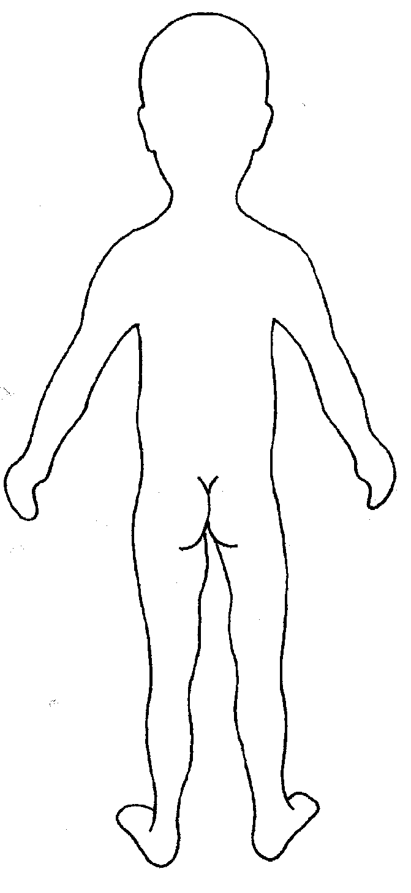

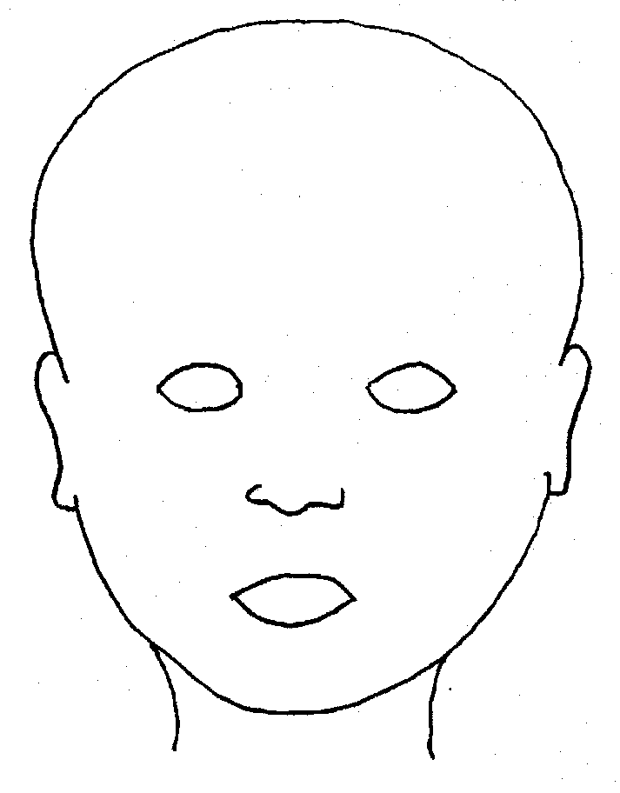 |  | 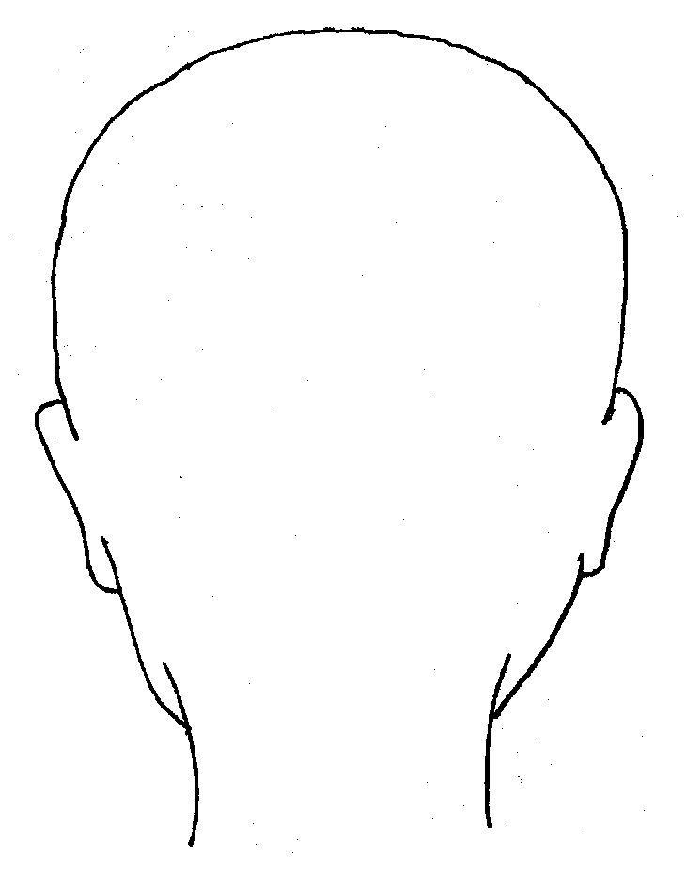
FRONT |  | BACK
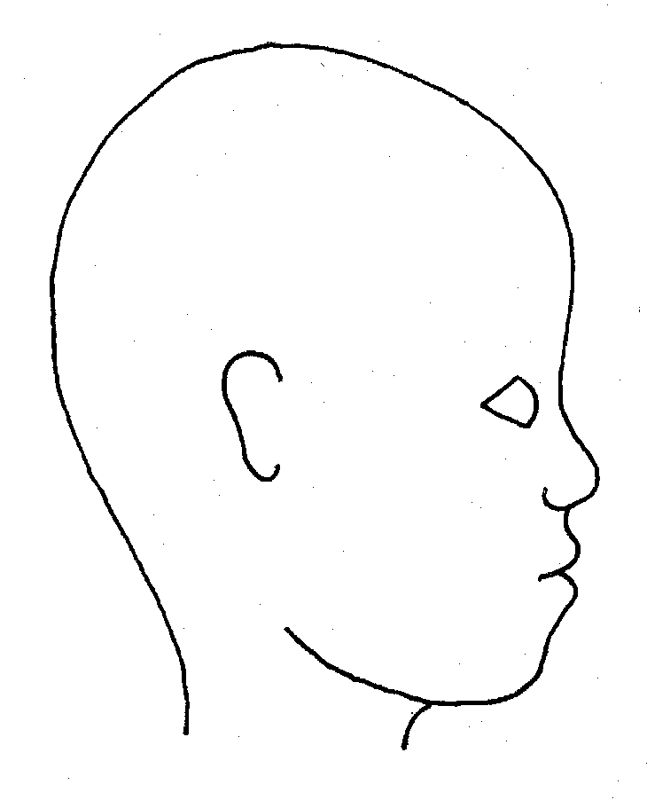 |  | 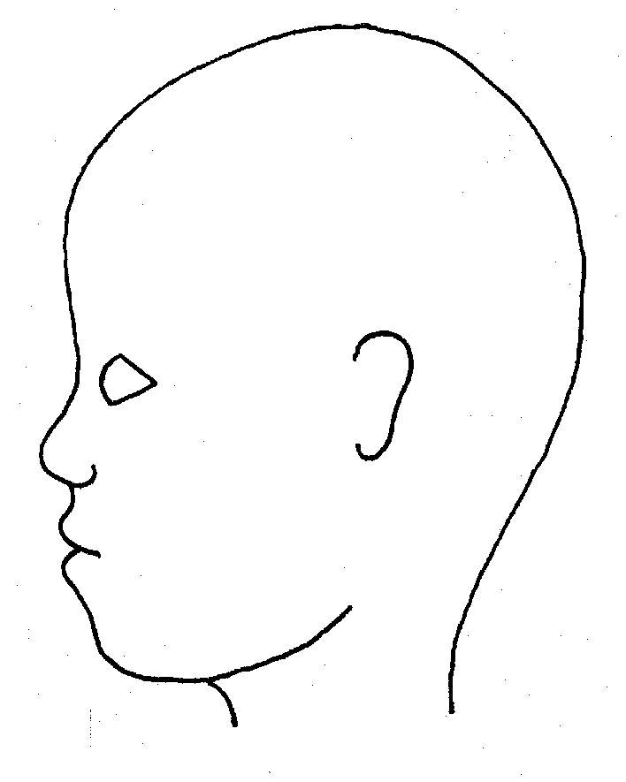
RIGHT |  | LEFT

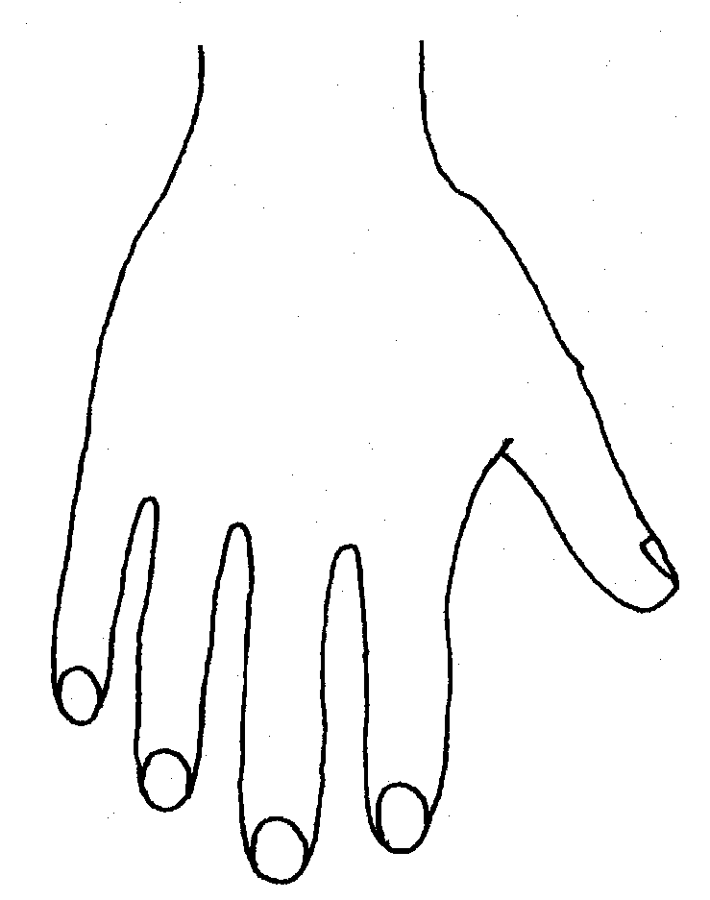 |  |  |  |  | 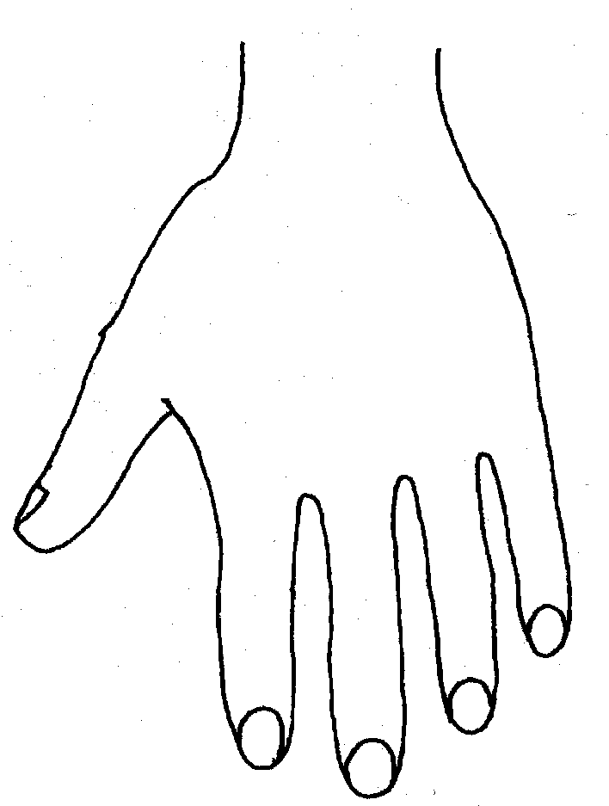
R |  |  |  |  | L
BACK
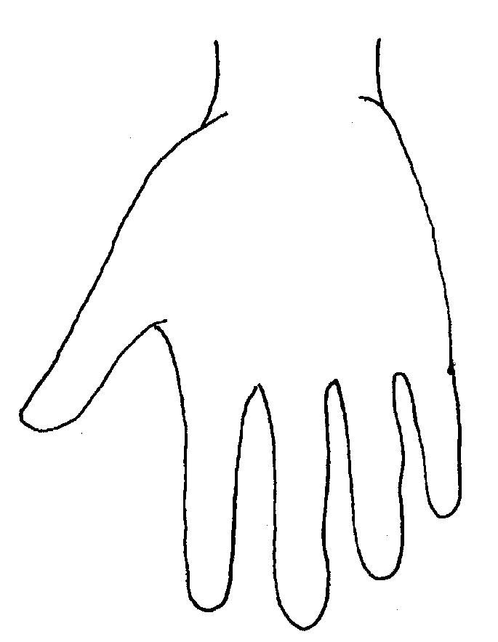 |  |  |  |  | 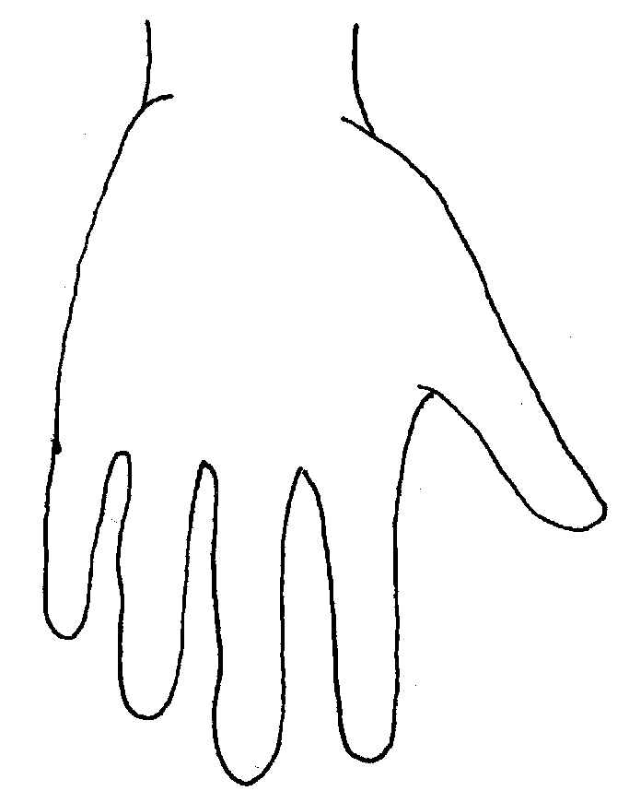
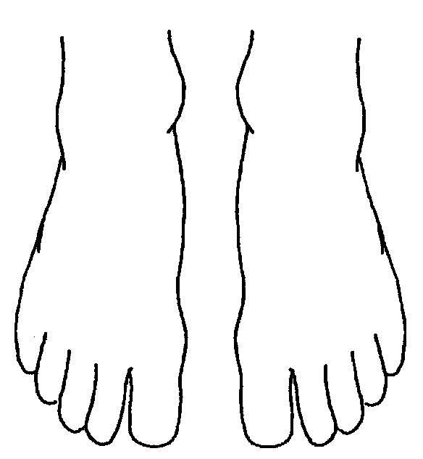 |  |  |  |  |  | 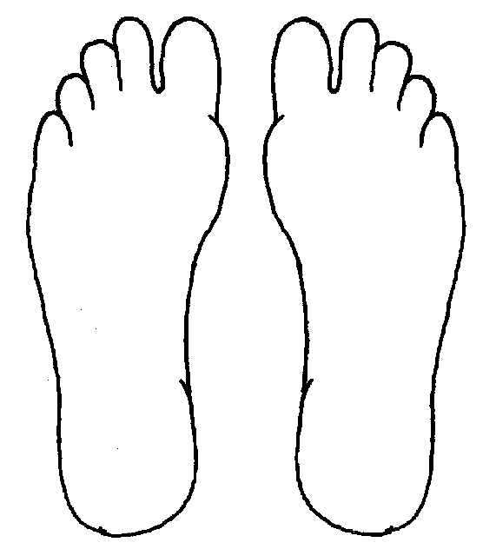
R | TOP |  |  | L |  | R |  | BOTTOM |  |  |  | L
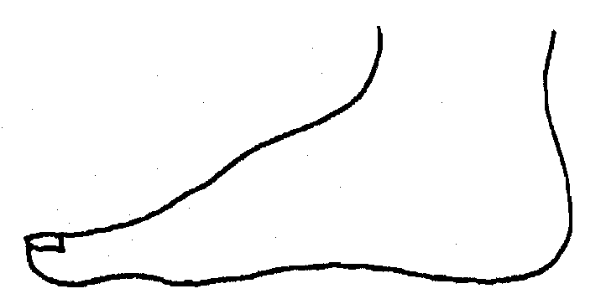 |  |  |  |  |  | 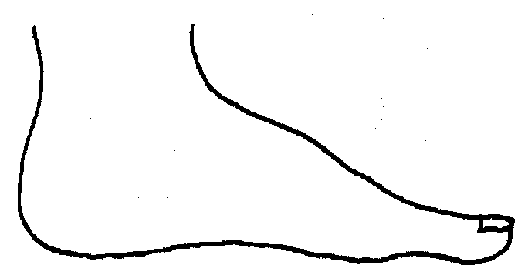
R |  |  |  |  |  | L
INNER
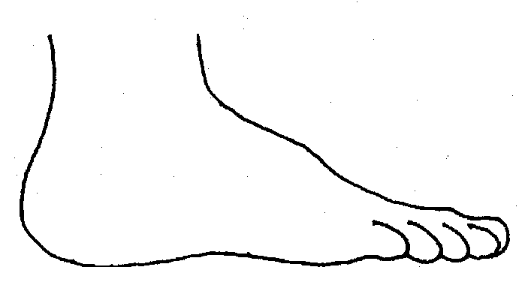 |  |  |  |  |  | 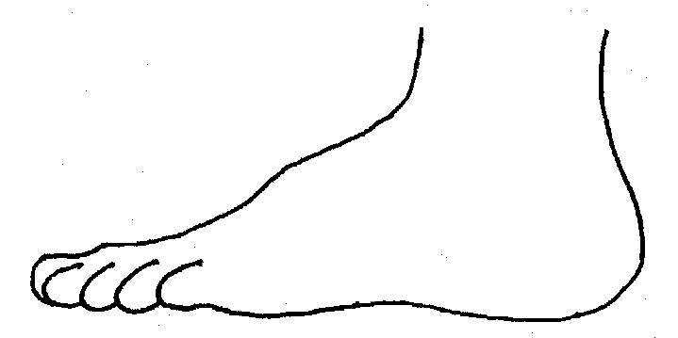
R |  |  |  |  |  | L
OUTER

